Manual Testing Task

URL:  [myindia.sg](http://myindia.sg/)

 Producing an issue for manual testing task using the URL

Critical issue: login

Major issue: Customer registration

Minor issues: contact information, coupon

|  |  |  |  |  |  |
| --- | --- | --- | --- | --- | --- |
| Project Name | [myindia.sg](http://myindia.sg/) |  |  |  |  |
| Test Case Id | Feature | Test Steps | Expected Result | Actual Result |  |
| 1 | Login | Verify that the system handling the incorrect format of mail id | The system should detect the wrong mail format and gives the alert message | The system is not detecting the wrong mail format and not giving the alert message |  |
|  |  | Verify that the user’s password is encrypted  After the encrypted icon is clicked | The password should be encrypted | The password is stored as the plain text |  |
| 2 | Coupon alert message | Verify coupon alert message alignment | The Alignment should be in correct format as coupon code | The  Alignment as coupon name is not correct and disappeared  After 3 secs without user permission |  |
| 3 | Customer registration | Verify the system handles correct format of mobile number during registration | The system should verify their mobile number before completing the process | The system only takes the eight digits of mobile number  During the registration process |  |
| 4 | Captcha  Customer registration | Verify the captcha  Alert message  Is displayed after clicking the captcha button | The captcha alert message should not be displayed  after clicking the captcha button | The captcha alert message is displayed  after clicking the captcha button |  |
| 5 | Account information | Verify the phone number in the account information | The phone number should be displayed as numbers only | The phone number filed as number and also having the scrolling icon |  |
| 6 | Wishlist | Verify the Wishlist in the home page | By clicking on Wishlist  the email id should not be disappeared | By clicking on the Wishlist  The  email id is disappeared |  |
| 7 | Contact information | Verify the company data in the contact info | The company data should have the correct information | The company information have been mistakes the word private short form as “pvt” instead of that having “pte” |  |
| 8 | Product image | Verify the product name and product image is same | The product name and product image should be same | The product name is not same as the product image |  |
| 9 | Misspelled word | Verify the word available in the home page | The word should be as available | The word available is not completed only having the avail |  |
| 10 | Format issue | Verify the scrolling line dollar symbol in the home page | The dollar symbol should be displayed before the amount | The dollar symbol should be displayed after the amount |  |

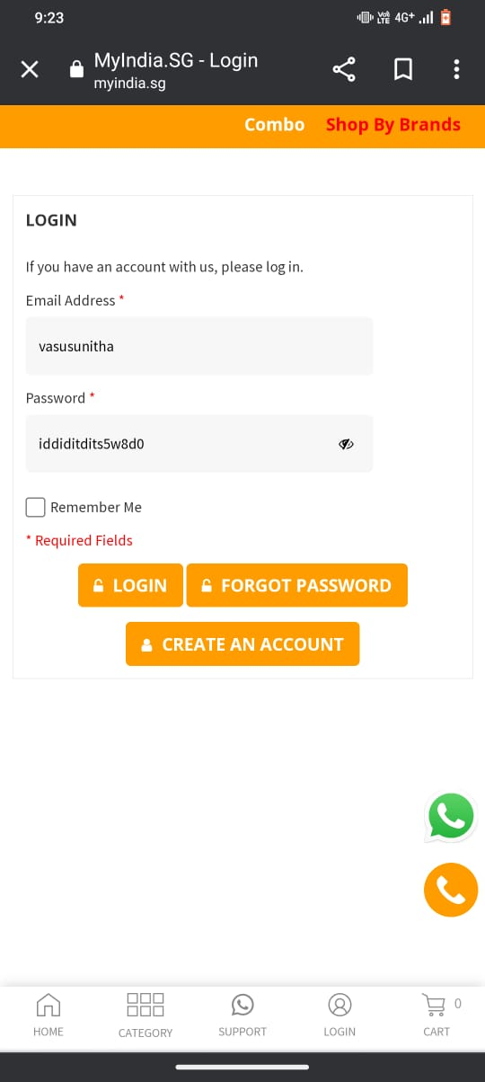

1

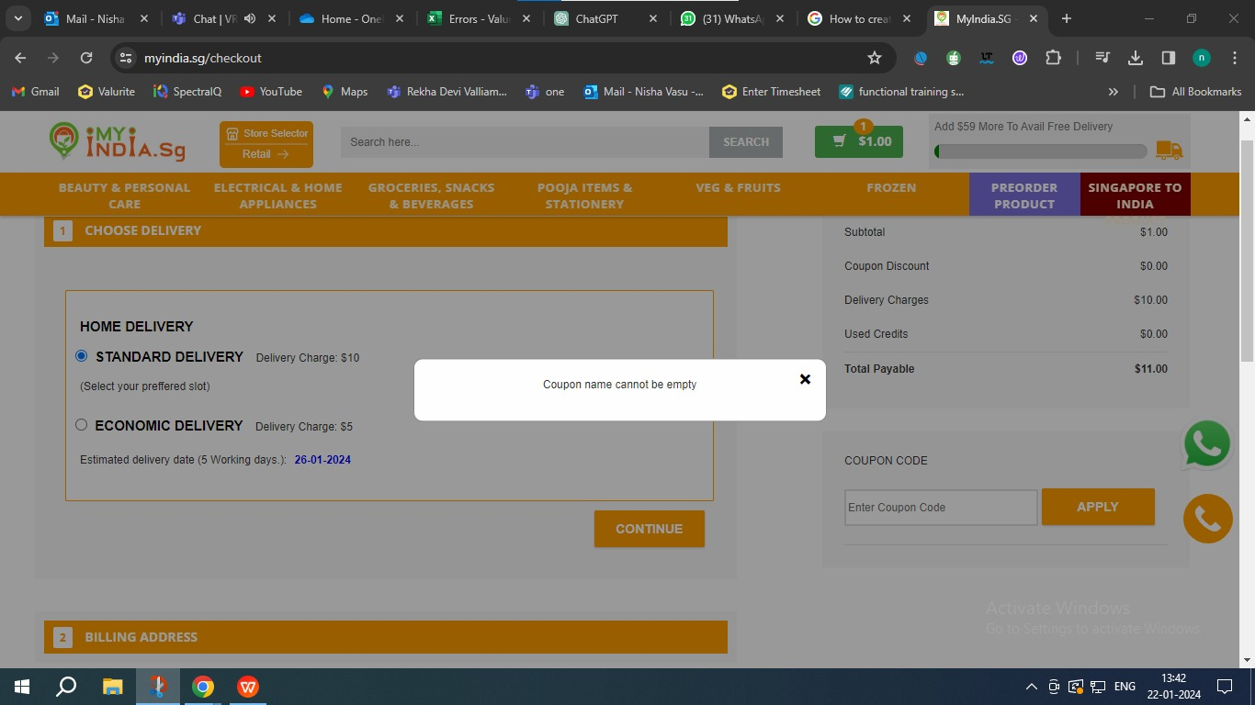

2

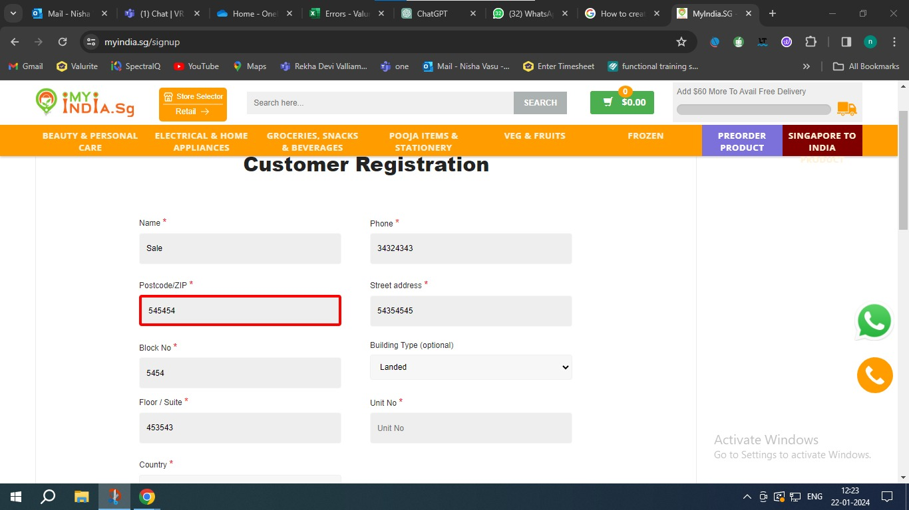

3

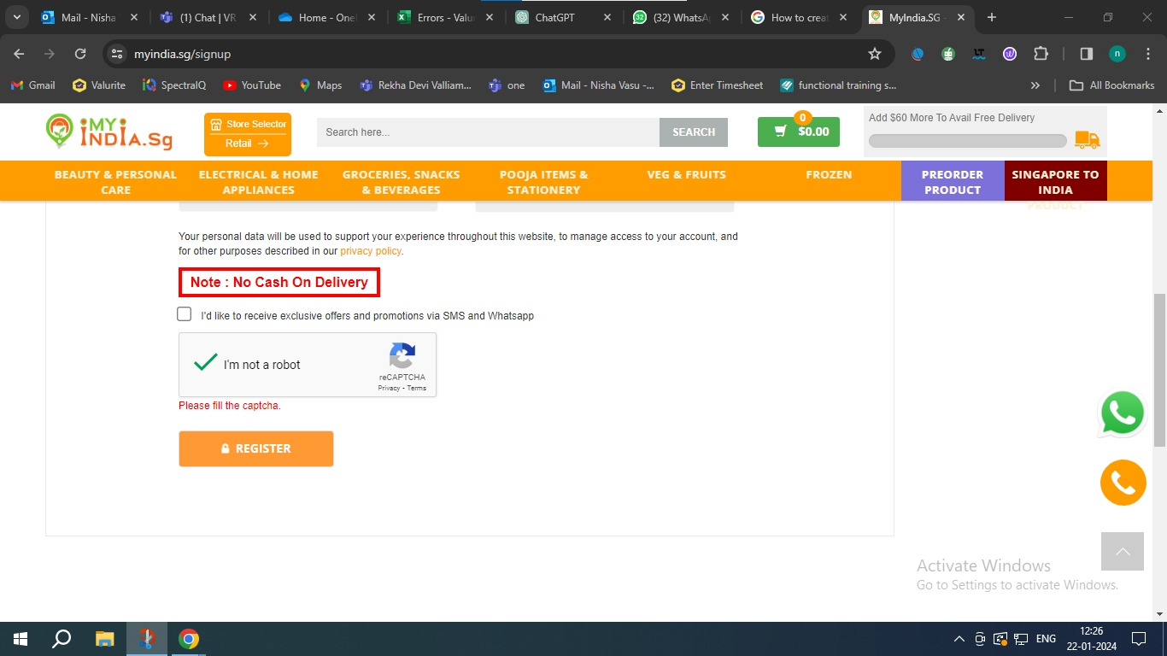

4

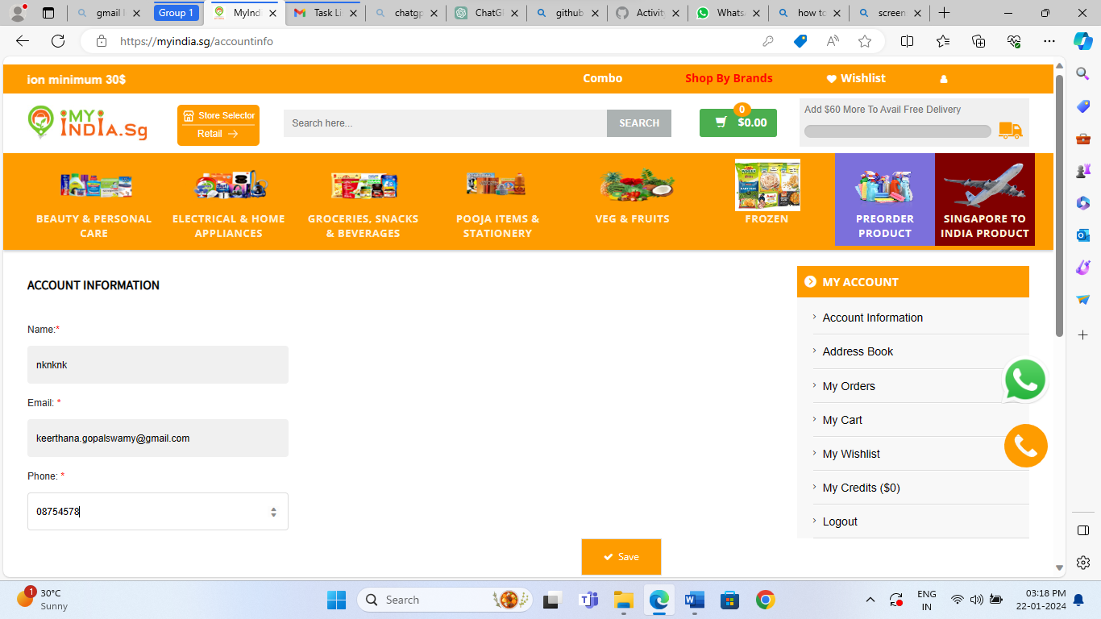

5

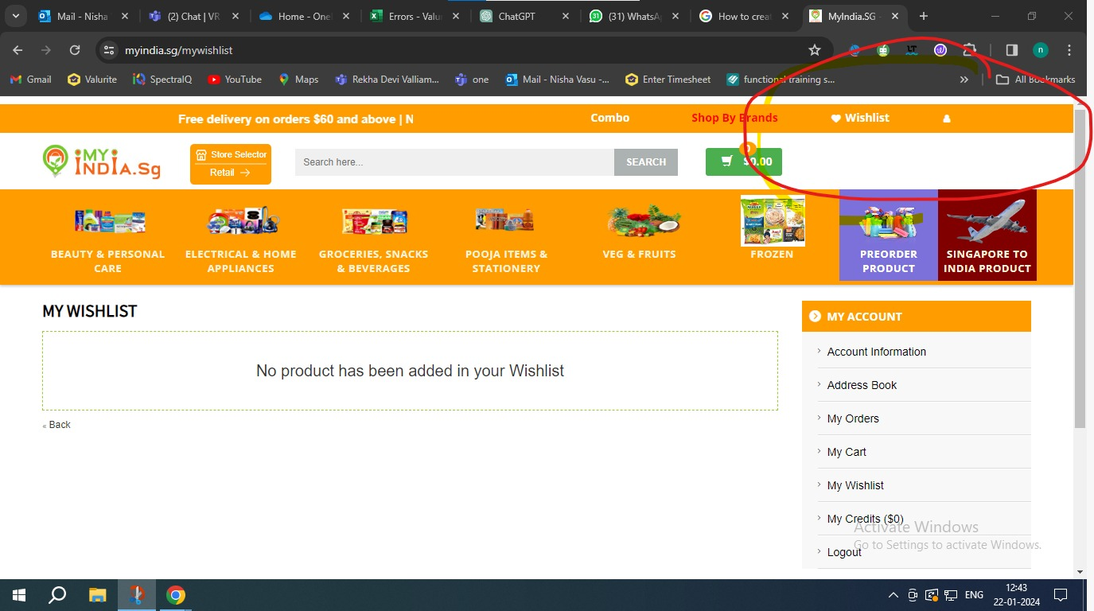

6

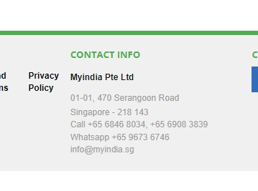

7

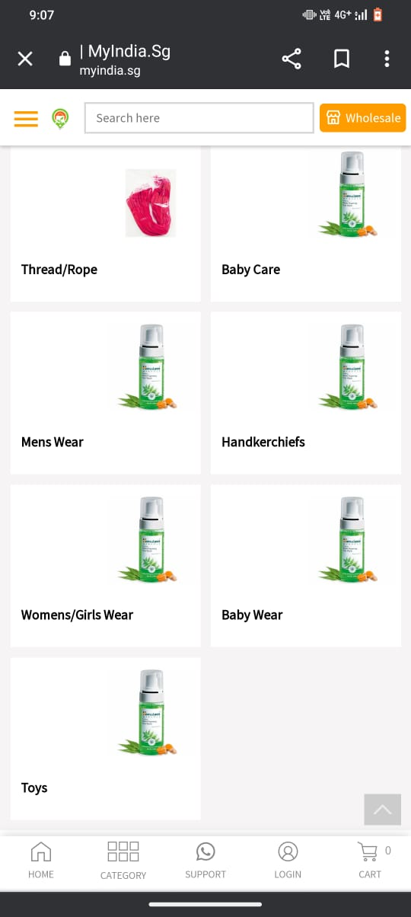

8



9

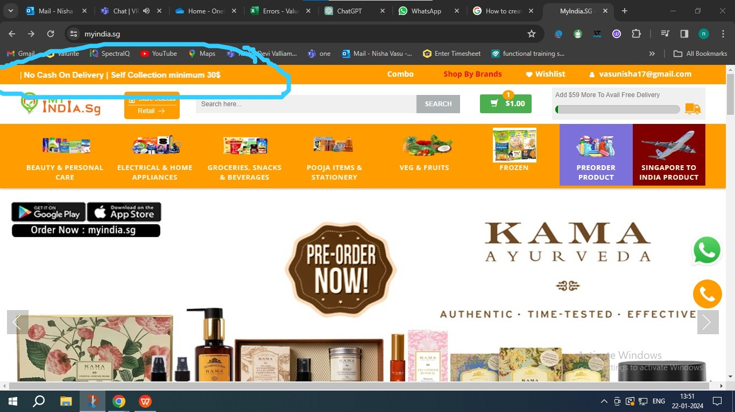

10